# 

# User Manual

# IOT using LoraWAN

TEAM F

Micheal (Team Leader)

Joel

Luis

Remi

James

CSE3PRA/CSE3PRB

Lecturer: Dr. Torab Torabi

Supervisor: Amin Abkenar

Copyright

CSE3PRB Industry Project 2019

Department of Computer Science and Computer Engineering

La Trobe University

Licensing and Warranty

IOT using LoraWAN is freeware: you can redistribute it and/or modify it under the terms of the GNU General Public License as published by the Free Software Foundation (version 3).

This program is distributed in the hope that it will be useful, but without warranty.

See the GNU General Public License for more details.

Available at https://www.gnu.org/licenses

1.0 Introduction

* 1. Audience Description

The documents objective is to help the users of the IOT using LoraWAN system, how to gain access and use the user interface.

Any stakeholders working on animal behaviours can be user of this system; Users will be viewing and monitoring animal behaviour through metrics and GPS map location, as well as the animal behaviour prediction. Users can view the UI once an administrator shares access.

The administrator main role is to place a sensor or sensors to an animal, and share/remove access to the UI.

1.2 Applicability Statement

Our system will run on any device that supports a browser; or in the case of smart phones or tablets, it can also be launched through an app.

The UI web app being used is Microsoft Power BI.

1.3 Purpose Statement

The main purpose of the system is to provide users with a simple, quick and intuitive means to measure, monitor and review animal behaviour through sensors, and visualize it by displaying it to a PC monitor, smart phone or tablet. It’s designed to deliver fast and easy to understand information with real-time metrics, location and behaviour predictions.

The major features are:

Simplification of animal behaviour measures through sensors, hardware and a user interface.

Capturing relevant information to make it easier to locate and see its current action at any point during its activity, as well as its action in a simple UI.

Enabling users to keep track of their actions (past and present) and the possibility of predicting (future) next action though an intuitive machine learning installed in the raspberry PI.

1.4 Document Usage Description

The User Document contains the following sections:

1. **Introduction**

Introduction of the system and its purpose.

1. **System Introductory Kit**

System features and quick guide.

1. **User Manual**

List of services the system provides and a description of each.

1. **Installation Guide**

Guide of the steps required to prepare the hardware.

1. **System Administrator Guide**

Details necessary steps to maintain the system.

1. **Appendices**

Tables of subsidiary contents.

1. **Bibliography**

List of source materials

1. **Glossary**

Definition of some terms using in the document.

1. **Index**

Alphabetical lists of names, subjects, etc with reference to the document page.

1.5 Conventions

The conventions used to create the User Document include headings, sizing, spacing, section separation, navigation to help identify the different parts contained within this document. The document was created word and then converted to PDF for security purposes.

Every table and figure have a unique number and description so the lists containing these objects is easy to follow and maintain.

2.0 System Introductory Kit

2.1 Summary of system features

IOT using LoraWAN is a User Interface solution that makes easy to track and monitor animal behaviours. The system depends on a sensor that sends raw information to the hardware, then translated with analytics streaming to be stored inside a database, finally visualizing real-time and easy to understand information to end users through a UI.

The movements, actions and GPS tracking are recorded through a Raspberry Pi with a sensor and the captured data will be sent to an IOT Hub for processing. The UI will be a Microsoft desktop and web app with native smartphone deployment options for different platforms accessibility.

The system is broken down into four parts:

Sensor: Worn by an animal or human which measures GPS, speed, etc.

Hardware: Automated tasks. Operates as the connection between the sensor and server.

Server: Analytics streaming and stores data, which then can be visualized by the UI. The server is a cloud-based service provided by Microsoft Azure.

UI: this is what a user sees and provides interaction between the user and the sensor.

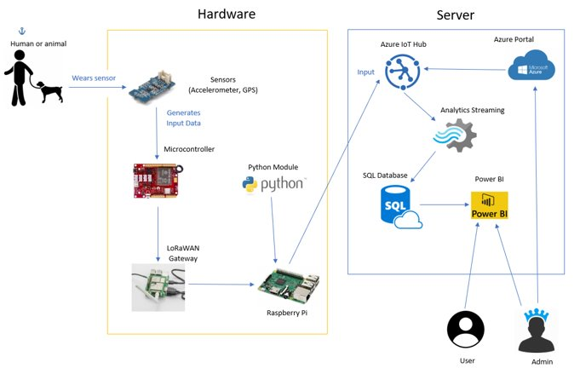

*Figure 1 - IOT using LoraWAN system diagram*

2.2 Getting started guide

This part will briefly explain the steps needed for the users to interact with the UI.

Can be one or more users, since the app is web based, any PC or portable devices can access it.

The web app used is called Power BI. The administrator can share to other users the Power BI UI report or dashboard with valid user credentials. Since the UI is only in read-only for end-users, there will be no problem for the administrator.

List of things users can view using IOT using LoraWAN system:

POWER BI:

* Sensor Number
* Sensor(s) GPS real time location
* Heat Map
* GPS tracking
* Action detection in a table
* Pie Chart of which behaviour has been done more often
* Table with latitude, longitude, date & time, sensor id and behaviour

3.0 User Manual

This section shows how to access the Power BI.

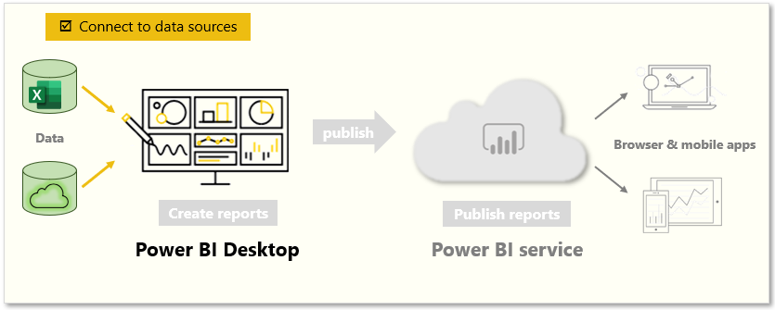 *Figure 2 – PowerBI Database connection overview*

This table will point out the services/functionality on the administrator side.

|  |  |
| --- | --- |
| **#** | **Service / Functionality** |
| 1. | Login or create account |
| 2. | Connection to existing database |
| 3. | Creation of visual objects |
| 4. | Saving and sharing |

*Table 1 – Administrator Service/Functionality*

This table will point out the services/functionality on the user side.

|  |  |
| --- | --- |
| **#** | **Service / Functionality** |
| 1. | Login or create account |
| 2. | Connection to shared report |

*Table 2 – End user Service/Funcionality*

3.1 Power BI User Login

This is the login screen for both administrator and users.

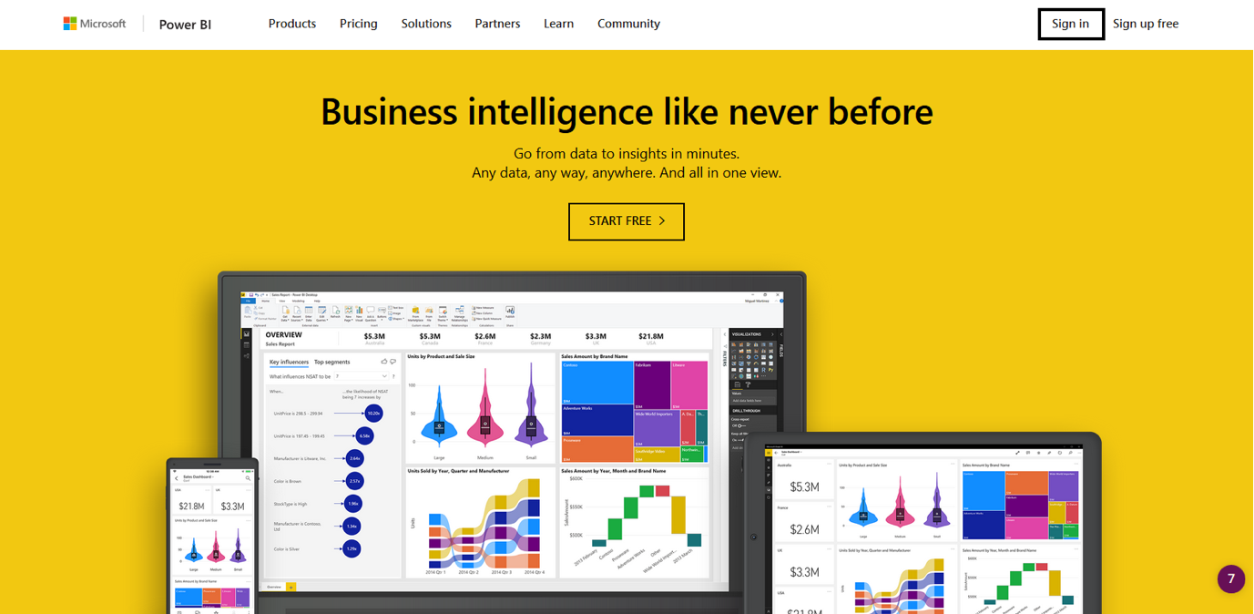

*Figure 3 – PowerBI Login Screen*

If you already have signed up, simply sign in; If not, sign up now. Signing up is the same as creating an email, it is simple and a credit card is not required. Alternatively, you can sign in or up with your portable device.

Once you have signed in, the next screen will appear.

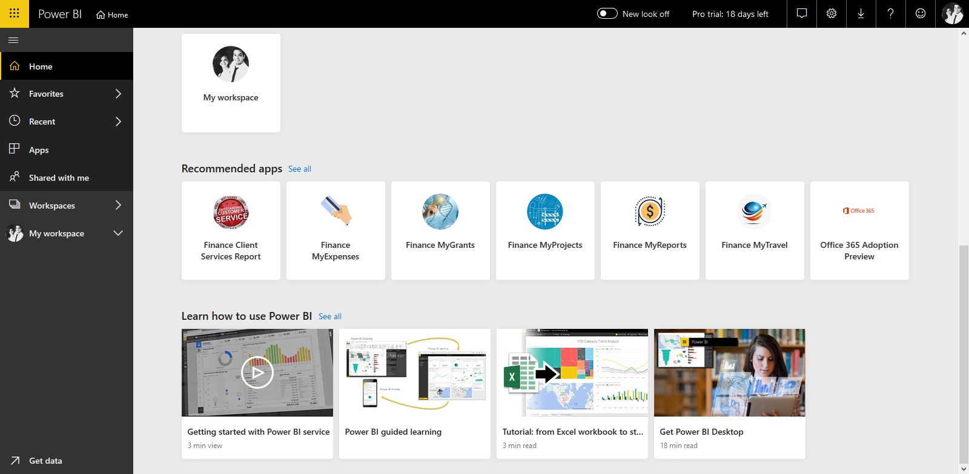

*Figure 4 – PowerBI Main Menu*

**Administrator**

Can only be done by using power BI desktop version, the web version doesn’t allow database connections.

In the bottom left of the screen there is an option called GET DATA, with this you can access the Microsoft database allocated in the azure cloud. You want to access the database.

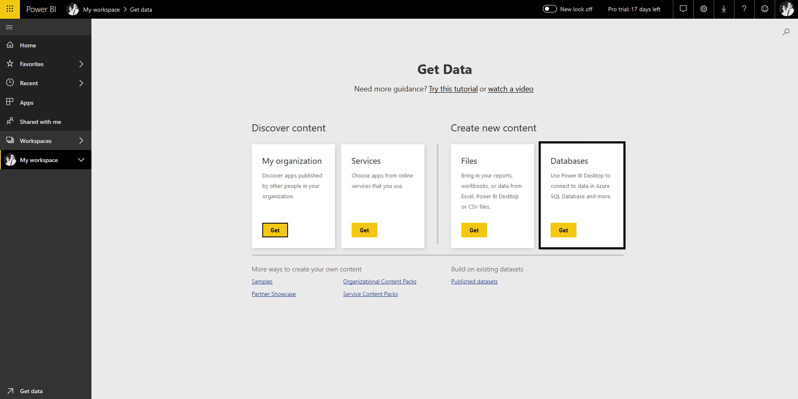

*Figure 5 – PowerBI Administrator Database connection menu*

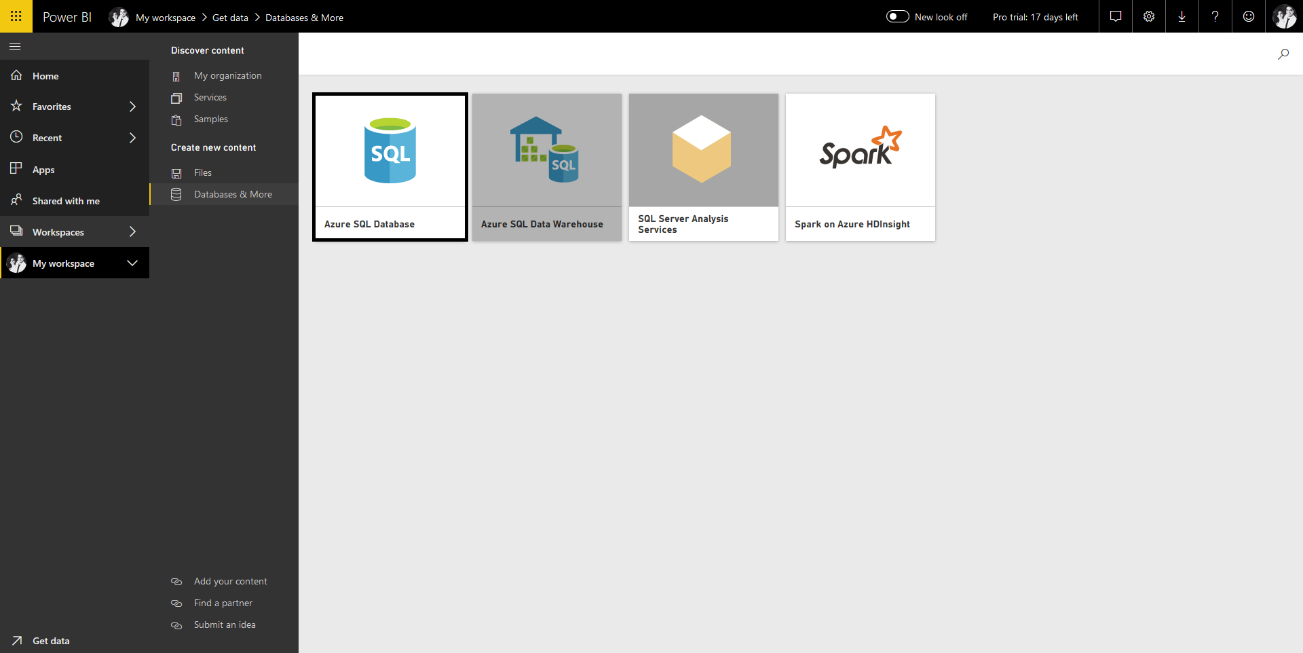

*Figure 6 – PowerBI Administrator menu Azure Database*

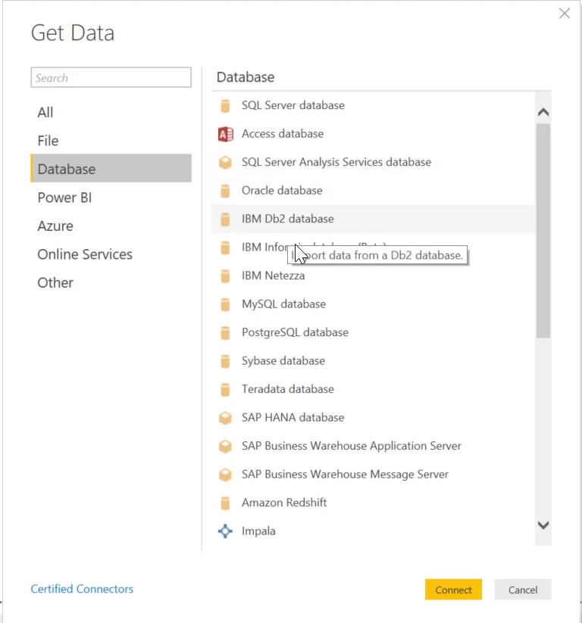

*Figure 7 – PowerBI Database connection menu Database options*

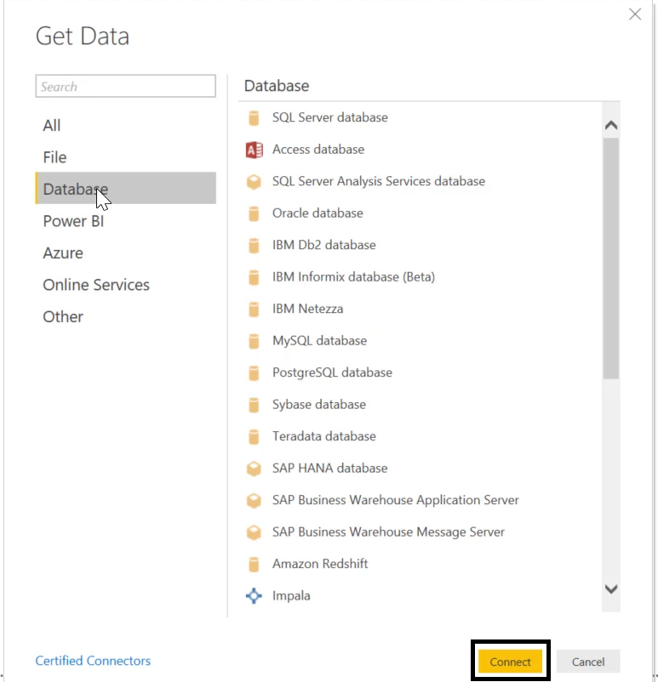

*Figure 8 – PowerBI Database connect*

Once SQLs tables have loaded you can start using the visual graphs.

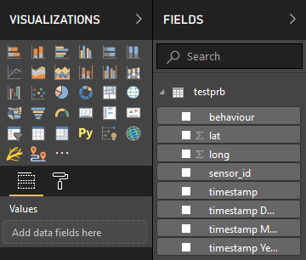

*Figure 9 – PowerBI Visualization Graphs*

To fill in the visualization table with data from the database table, in the FIELDS section, choose the desired camps.

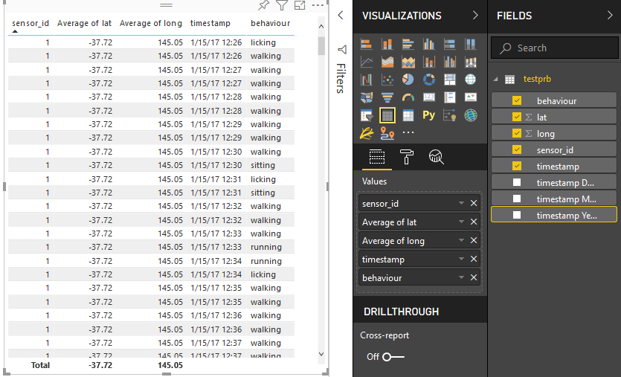

*Figure 10 – PowerBI Table Graph*

And the same is applied to the Pie Chart and Map.

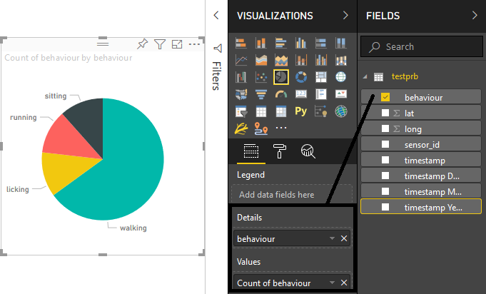*Figure 11 – PowerBI Pie Chart*

With the pie chart is little different, since we need to fill the camps in details and values. We just drag “behaviour” from our database table to “details” and “value”.

For the Map we will use ArcGIS map for Power BI.

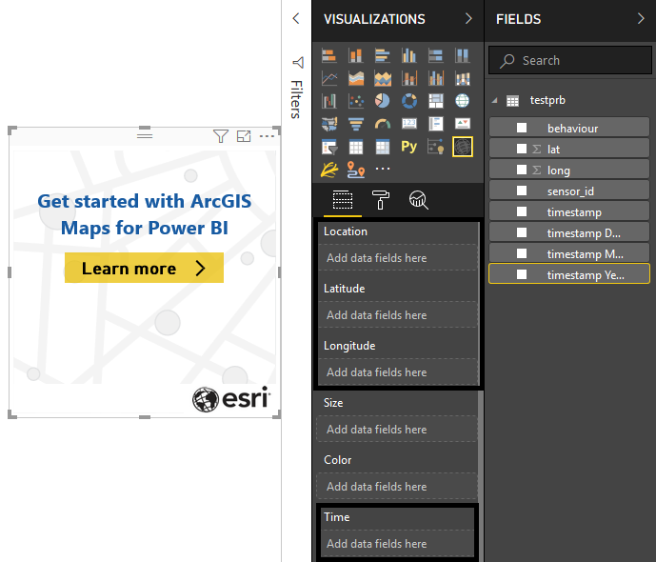

*Figure 12 – PowerBI ArcGIS Map*

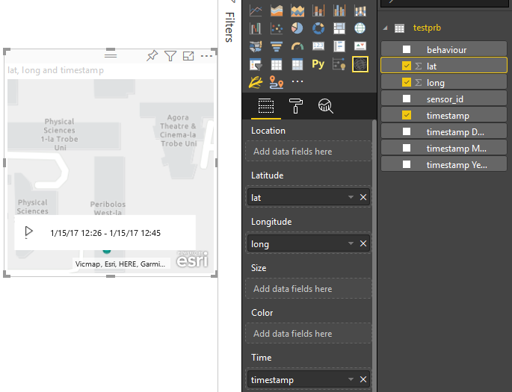

*Figure 13 – PowerBI ArcGIS Map Fields*

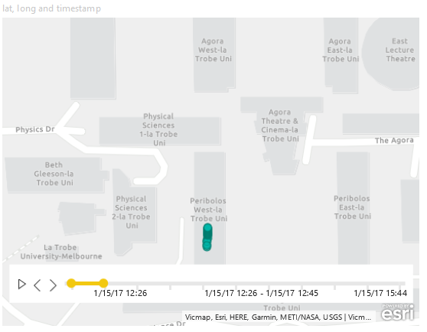

*Figure 14 – PowerBI ArcGIS Map GPS location*

To get the heat map, we can edit the map with the three dots in the upper right corner of the map.

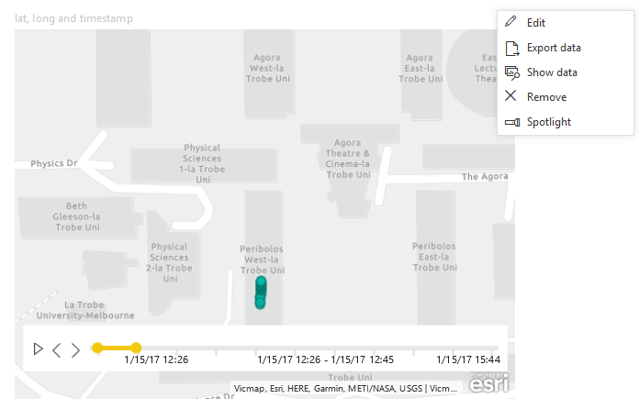

*Figure 15 – PowerBI ArcGIS Map Edit Options*

Change the base map to streets, which has richer colours.

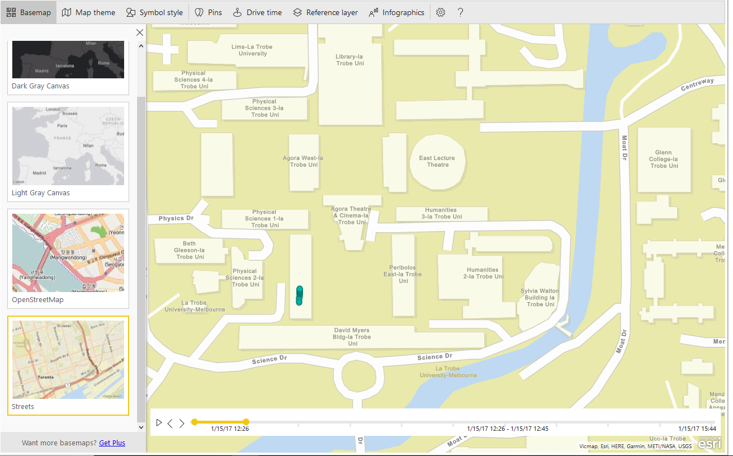

*Figure 16 – PowerBI ArcGIS Map Basemap*

For the heat map we go to map theme and select the heat map.

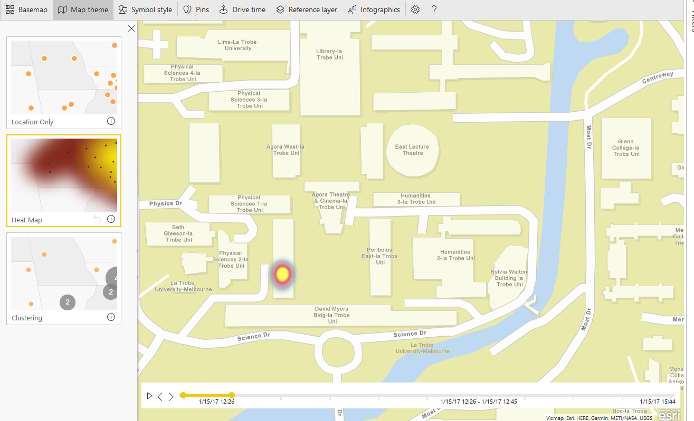

*Figure 17 – PowerBI ArcGIS Map Theme*

As you can see, since we have a timestamp value on the map, a slider on the bottom of the map is available, with this we can go back or forth in time to see the path or location of certain behaviours.

Once all desired visual graphs are selected and filled with the proper values, we will achieve our desired UI.

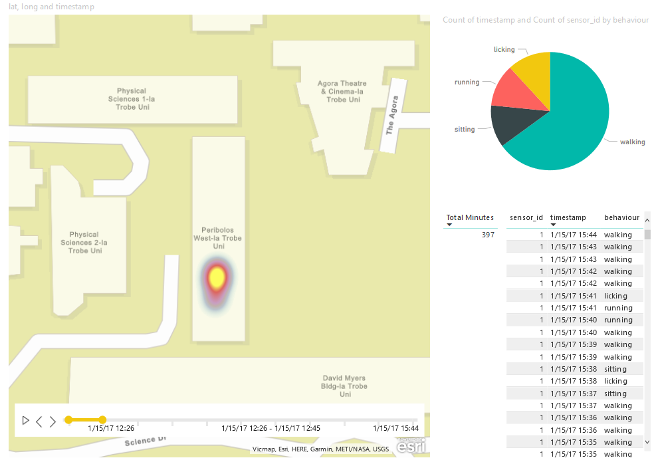

*Figure 18 – PowerBI ArcGIS Heat Map*

To share the report, we simply click on the upper menu, SHARE

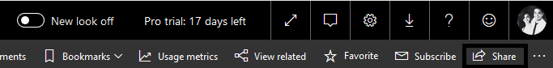

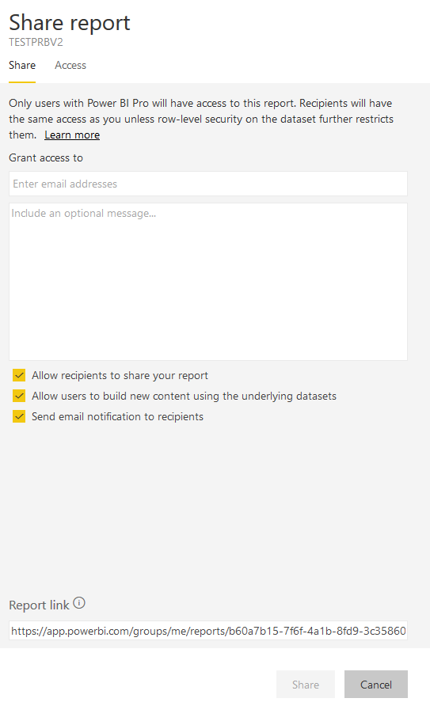

*Figure 19 – PowerBI Report/Dashboard sharing*

This share option will only give read permissions to any other users. So sensitive data will always be safe.

**Users**

Users can gain access really simple. The only thing you need is the administrator to share the report so you can gain access to the visual graphs. Take note that users can only view and don’t have permission for edition.

On the left menu column, select shared with me option.

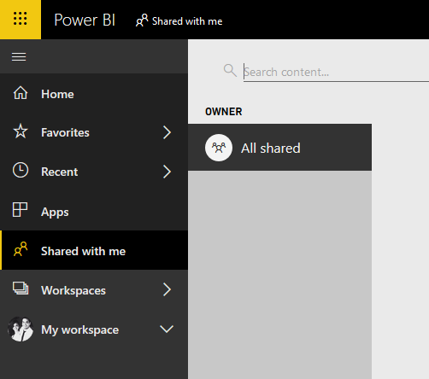

*Figure 20 – PowerBI User: Shared with me*

All reports shared to the user will be on the middle work space.

Once gained access to IOT using LoraWAN system, the user will be able to visualize what the administrator has created and shared.

This visual report will be dynamic, so you can click on any behaviour and it will show you in the map and table.

In the example below, running was clicked in the pie chart.

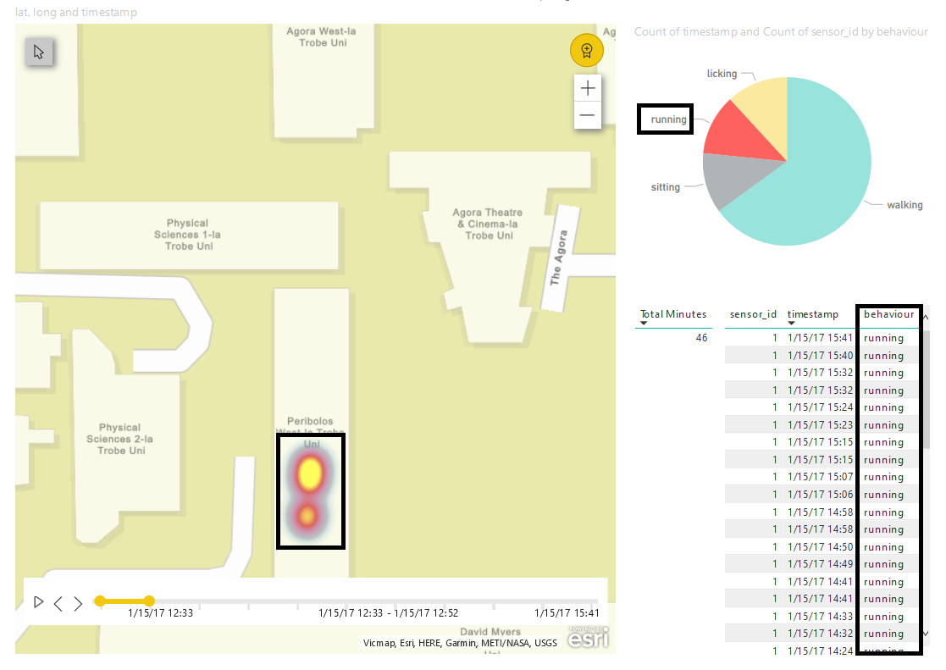

*Figure 21 – PowerBI User UI*

6.0 Appendices

|  |  |  |
| --- | --- | --- |
| Figure Number | Figure Name | Page |
| Figure 1 | IOT using LoraWAN System Diagram | 11 |
| Figure 2 | PowerBi Database Connection Overview | 13 |
| Figure 3 | PowerBI Login Screen | 14 |
| Figure 4 | PowerBI Main Menu | 15 |
| Figure 5 | PowerBI Administrator Database Connection Menu | 16 |
| Figure 6 | PowerBI Administrator Connection to Azure Database | 16 |
| Figure 7 | PowerBI Administrator Database Options | 17 |
| Figure 8 | PowerBI Administrator Database Connect | 18 |
| Figure 9 | PowerBI Visualization Graphs | 19 |
| Figure 10 | PowerBI Table Graph | 19 |
| Figure 11 | PowerBI Pie Chart | 20 |
| Figure 12 | PowerBI ArcGIS Map | 21 |
| Figure 13 | PowerBI ArcGIS Map Fields | 22 |
| Figure 14 | PowerBI ArcGIS Map GPS location | 22 |
| Figure 15 | PowerBI ArcGIS Map Edit Options | 23 |
| Figure 16 | PowerBI ArcGIS Map Basemap | 23 |
| Figure 17 | PowerBI ArcGIS Map Theme | 24 |
| Figure 18 | PowerBI ArcGIS Heat Map | 25 |
| Figure 19 | PowerBI Administrator Report/Dashboard sharing | 26 |
| Figure 20 | PowerBI User: Shared with me | 27 |
| Figure 21 | PowerBI User UI | 28 |

Appendix 1 – Table of Figures

|  |  |  |
| --- | --- | --- |
| Table Number | Table Name | Page |
| Table 1 | Administrator Services/Functionality | 13 |
| Table 2 | End user Services/Functionality | 13 |

Appendix 2 – Table of Tables

7.0 Bibliography

CSE3/5PRA & CSE3/5PRB Industry Project - 2019 Handbookv2.0

Lecture materials:

* Example User Manual
* User Manuel Marking Criteria
* Week 2 Workshop – Usability Testing
* Week 6 Lecture – Process Improvement

Microsoft.com for:

* Microsoft Azure
* PowerBI
* SQL

Thethingsnetwork.org for:

* Arduino
* IOT
* LoraWAN

Raspberrypi.org for:

* Raspberry Pi

Seeedstudio.com for:

* Seeeduino

Python.org for:

* Python

8.0 Glossary

**IoT:**

The Internet of things is the extension of Internet connectivity into physical devices and everyday objects. Embedded with electronics, Internet connectivity, and other forms of hardware, these devices can communicate and interact with others over the Internet, and they can be remotely monitored and controlled.

**LoRaWAN:**

LoRaWAN is a media access control (MAC) protocol for wide area networks. It is designed to allow low-powered devices to communicate with Internet-connected applications over long range wireless connections.

**SQL:**

SQL is a domain-specific language used in programming and designed for managing data held in a relational database management system, or for stream processing in a relational data stream management system.

**Microsoft Azure:**

Microsoft Azure is a cloud computing service created by Microsoft for building, testing, deploying, and managing applications and services through Microsoft-managed data centers.

**Raspberry Pi:**

The Raspberry Pi is a series of small single-board computers used to promote teaching of basic computer science in schools and in developing countries.

**Arduino:**

Arduino is an open-source hardware and software company, project and user community that designs and manufactures single-board microcontrollers and microcontroller kits.

**Seeeduino:**

Seeeduino V4.2 is an Arduino-compatible board, which is based on ATmga328P MCU.

**Power BI:**

Power BI is a business analytics service by Microsoft. It aims to provide interactive visualizations and business intelligence capabilities with an interface simple enough for end users to create their own reports and dashboards.

**Python:**

Python is an interpreted, high-level, general-purpose programming language.

9.0 Index